HARO Sports Flooring

Good, better, Supercup!

HARO Sports supplies the floor for the Basketball Supercup 2015 in Hamburg
Rosenheim – The Supercup is the most traditional basketball tournament in Europe and was carried out for the 21st time this year. It took place at the Wilhelmsburger Inselparkhalle in Hamburg from the 21. – 23. August 2015. Fans were excited to see a famous guest: Superstar Dirk Nowitzki came to the EM training tournament.

High-Class in the far north
The Supercup is an international basketball tournament for national teams that happens somewhere else each year. This time it was hosted at the Wilhelmsburger Inselparkhalle in Hamburg, home of the Hamburg Towers, where the German national players played against Turkey, Poland and Latvia. The Supercup also served as a training tournament for the European Championship, which took place two weeks later. It is probably the most traditional basketball tournament in Europe and has been happening annually since 1987. Germany hasn’t missed it once. The highlight was definitely the basketball superstar Dirk Nowitzki, who was there as well.

Because of the German players’ outstanding performance, Germany was able to score the first place, followed by Latvia and Poland and Turkey coming last.
Not only the players are important though. You do need the right floor: the portable sports floor „ROME 20“ from HARO sports gave the tournament a special touch.

Mobile performance

For more than half a century HARO Sports Flooring, the sports flooring department of the leading parquet manufacturer Hamberger Flooring in Germany, has been producing mobile and permanently installed sports floors. The Wilhelmsburger Inselparkhalle also has a permanently installed HARO sports floor. The mobile „ROME 20“ was installed on top of it for the tournament. Athletes, investors and arena operators all over the world associate it with durability and excellent performance characteristics. ROME 20 minimizes the impact on athlete’s bodies and prevents injuries. Players say the floor adds an extra season to their careers. Last but not least, ROME 20 enhances the players’ leg power and its excellent ball rebound speeds up the game.

The modules of this portable floor weigh less than 35 kg and guarantee effortless handling. The northern birch plywood construction and the hardwood top layer make the modules extremely durable and dimensionally stable. The floor is fast and simple to install and dismantle. A fast-motion video demonstrates that ROME 20, including the portable basketball backstops, can be easily installed by six people in only 2:20 hours.

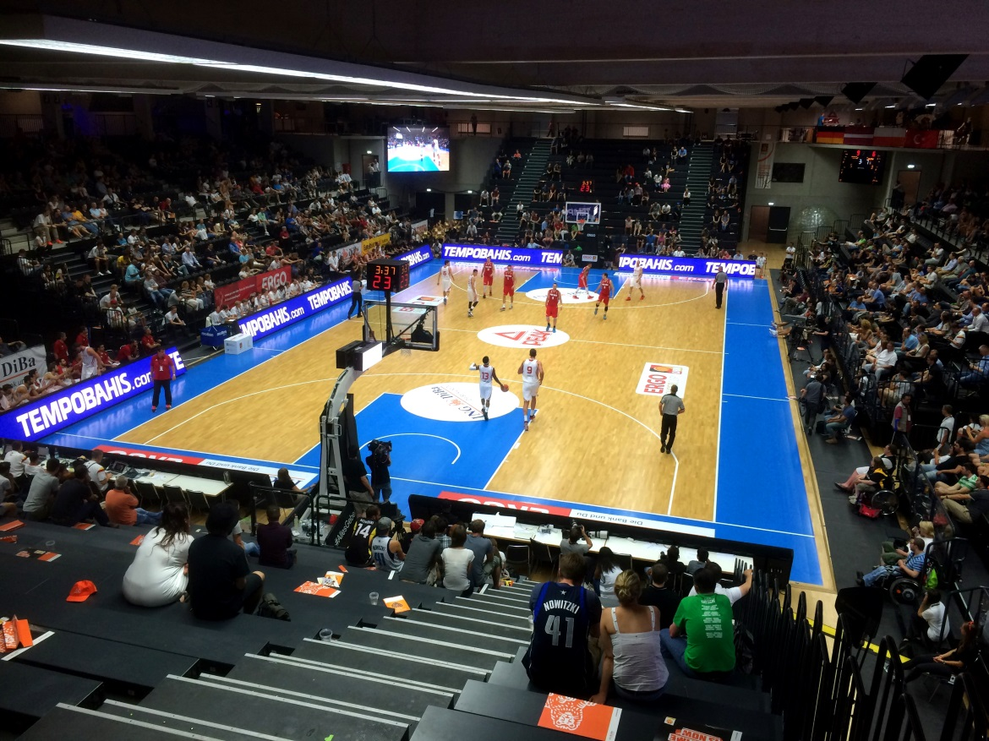
The Wilhelmsburger Inselparkhalle also has a permanently installed HARO sports floor. The mobile „ROME 20“ was installed on top of it for the tournament.

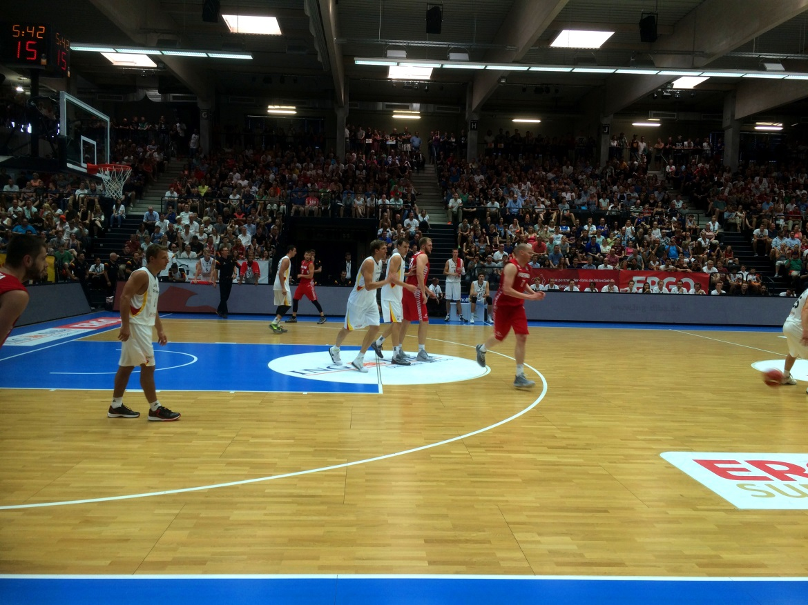Fans were particularly thrilled to see superstar Dirk Nowitzki (middle).

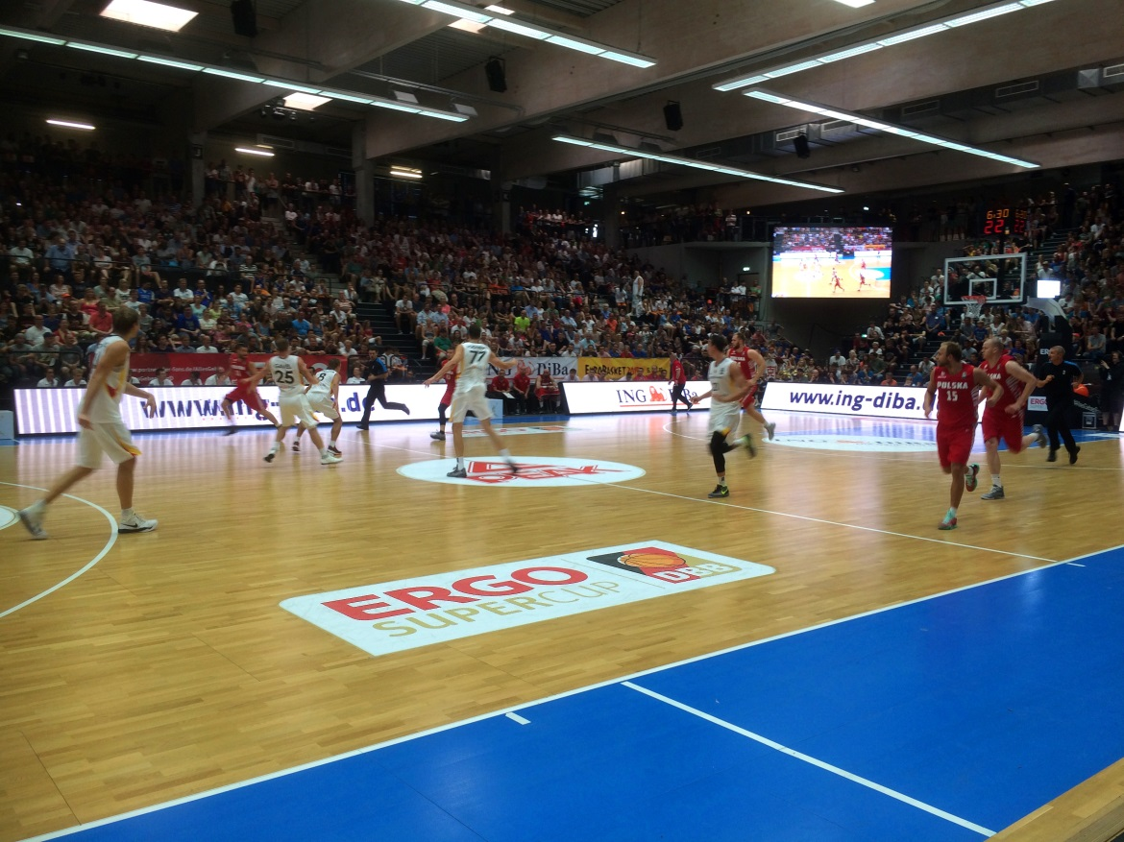
Athletes, investors and arena operators all over the world associate “ROME 20” with durability and excellent performance characteristics.

……………………………………………………………………………………………...
Fotos: HARO Sports Flooring
Abdruck frei. Belegexemplar erbeten.

Im Sportbodenbau werden unter der Marke HARO SPORTS Flooring seit 1958 mobile oder fest eingebaute flächenelastische Sportböden sowie Prallwände, Türen und Tore gefertigt. Entscheidern und Investoren bietet HARO SPORTS Flooring die Möglichkeit, sich von einem erfahrenen Spezialistenteam über die beste Bodenlösung in Sport- und Mehrzweckhallen umfassend beraten zu lassen. Die Hamberger Industriewerke GmbH in Stephanskirchen bei Rosenheim kann inzwischen auf über 60 Jahre Erfahrung in der Parkettherstellung zurückblicken. Das im Jahre 1866 gegründete Unternehmen wird heute in der vierten und fünften Generation von Peter Hamberger und Dr. Peter M. Hamberger geführt. Neben dem Unternehmensbereich Flooring mit Parkett, Kork- und Laminatboden sowie Celenio, umfasst die Hamberger Firmengruppe die Bereiche Sports Flooring, Sanitary, Sägewerk, sowie Land- und Forstwirtschaft. Bereits 1995 wurde Hamberger nach DIN EN ISO 9001 zertifiziert, 1998 folgte die Zertifizierung des Umwelt-Management-Systems nach DIN EN ISO 14001. Seit 2002 sind die Hamberger Industriewerke gemäß PEFC zertifiziert. Das Siegel ist ein Nachweis dafür, dass die verarbeiteten Rohstoffe aus zertifiziertem nachhaltig bewirtschaftetem Wald stammen. Mit über 2.000 Mitarbeitern setzt die Firmengruppe jährlich ca. 300 Mio. Euro um. Der Exportanteil des Unternehmens beträgt über 40%, der Export geht weltweit in mehr als 90 Länder. Weitere Informationen unter www.haro-sports.de.

